EXPERIMENT 5

DDL COMMANDS (COLLEGE SCHEMA)

Aim:

· Create a schema called College.

· Create tables for students (attributes: student id, name, gender, subject, marks and grade), faculty (attributes: faculty id, name, course and pass percentage), department (attributes: department id, name, section, strength and pass percentage) and activity (attributes: activity id, name, strength and category)

· Add and modify:

o Address in students table, change datatype size of student name and make student id primary key

o Add faculty total mentor details, make faculty id as primary key

o Add number of students in wise in department table and make department id as primary key

Add faculty name to activity table, change the datatype size of activity name and make activity id as primary key

1. Create schema college

2. Create table-student and attributes are studid, studname, gender, subject, marks, grade.

3. Create table-faculty and attributes are fac_id, fac_name, course, pass percentage.

4. Create table-department and attributes are dept_no, dept_name, section, no of students, pass percentage.

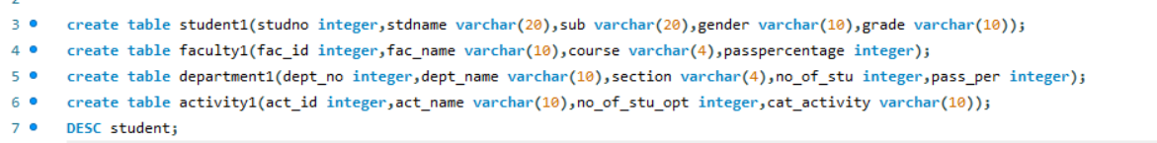

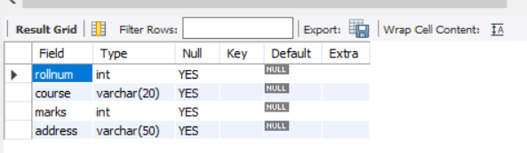

1.Add address in student table ,change the datatype size for student name and make studid as primary key.

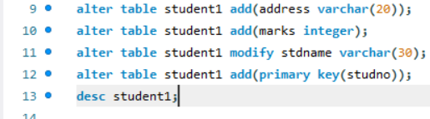

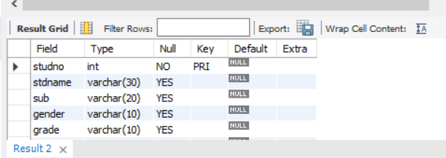

2.Add faculty total mentor details ,make4 fac_id as primary key.

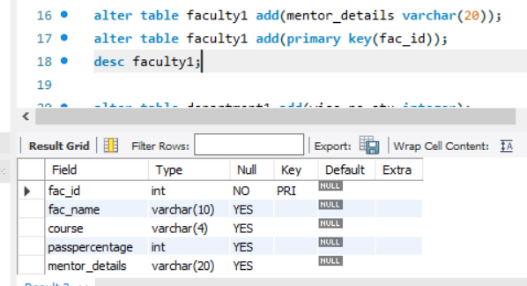

3.Add no of students in wise and make dept no as primary key.

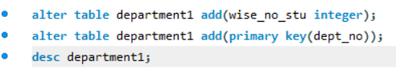

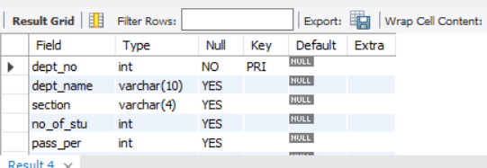

4.Add faculty name and change the size of act_name and act_id as primary key.

